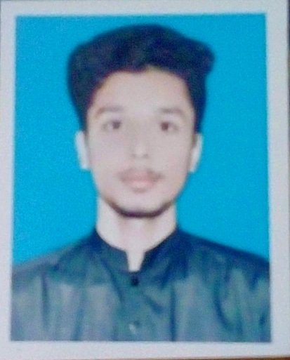**Hammad Ejaz**

+92-3104000276 hammadejaz2021@gmail.com

• <https://www.linkedin.com/in/hammad-ejaz-7a5b80243/> • Age: 19

Education

**UNIVERSITY OF ENGINEERING AND TECHNOLOGY LAHORE (3.4)**  Lahore, Pakistan

*Bachelor in Computer Science*  2022

**GOVT. COLLEGE of TECHNOLOGY RAILWAY ROAD LAHORE (92.60%)**  Lahore, Pakistan

*DAE in mechanical* 2018-2021

Professional Experience

**PAKISTAN RAILWAYS** Lahore, Pakistan

*Internee Jun 2019 - Jul 2019*

* *Interpersonal skills:* Communicated with Foremen and Sub engineers and thus learned critical technical concepts in 8 different workshops

Academic Experience

**DESIGN AND FABRICATION OF COMPUTER NUMERIC CONTROL 3D PRINTER (FYP)** Lahore, Pakistan

Collaborated with GCT using tools like SLITHER, PRONTER FACE and ANSYS Fluent

*Group Leader: Dec 2020 –June 2021*

*Group Leader of group “Not-Creative”*

Extracurricular Experience

**UET ASME SOCIETY** Lahore, Pakistan

* *Head Publicity:* Managed social media accounts and member of communication team

Honors and Awards

**ACADEMIC SCHOLARSHIPS**  Lahore, Pakistan

* Received full merit-based academic scholarship from UET (2022)
* High achiever awards in school and college (2015-2018)

Additional

* *Coding Skills:* PYHTON, C++, C#, html/CSS, Js, jQuery, SQL, React
* MS Office
* *Certifications:* FULL STACK WEB DEVELOPMENT (Course era, 2022), CREATIVE THINKING (Course era, 2022)
* *Interests:* Management, Helping People, Book Reading, Sports, Coding